Attorney says Bearpaw owner was negotiating with officials before federal indictment
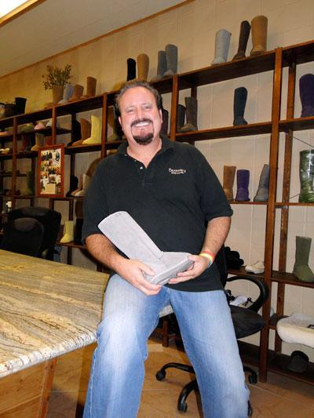
Bearpaw Footwear chief executive officer Tom Romeo, shown in 2011, holds one of the company's signature boots.
Bearpaw Footwear

By Mark Anderson
– Staff Writer, Sacramento Business Journal
Dec 5, 2014, 6:48am
An attorney for Citrus Heights shoe importer Tom Romeo, who was indicted Thursday, said his client has been negotiating with federal officials for years.
A federal grand jury in Sacramento on Thursday charged Romeo with evading about $5.6 million in customs duties. The company imports the popular Bearpaw brand of shearling slippers and boots and sells them nationally.
"Tom has been fully cooperating with customs over the past several years," said attorney Malcolm Segal, with Segal & Associates PC in Sacramento.
Romeo has deposited more than $4 million with U.S. Customs while the issue remains unsettled, Segal said.
Segal said the dispute arises from a technical issue over whether the shoes are completed products or component parts. The duties are different depending on how the shoes are classified.
Romeo owns and operates Romeo & Juliette Inc., a company that imports shoes and boots made in China and distributed under the brand names Bearpaw and Attix. The company sells to many national retailers.
The indictment alleges that from 1994 through 2011 Romeo had employees and others create false invoices that undervalued footwear he imported from China.
"Bearpaw has been a phenomenally successful company," Segal said. "We are eager to resolve this as soon as possible."

